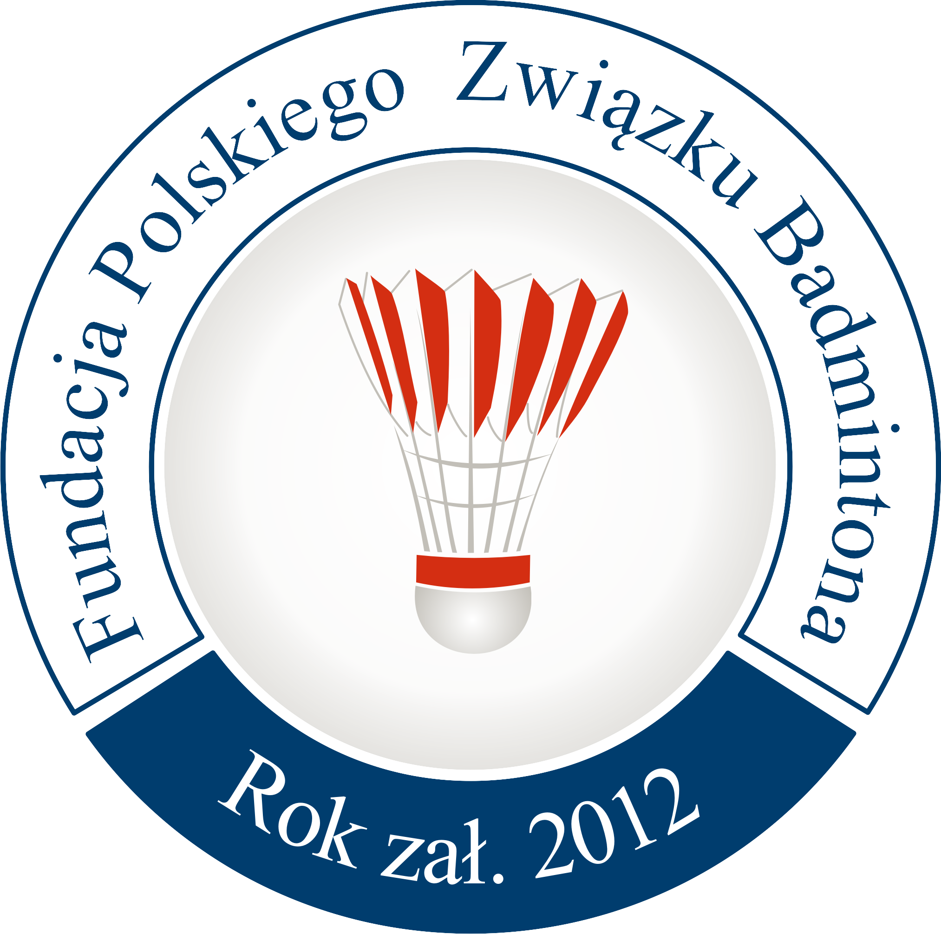
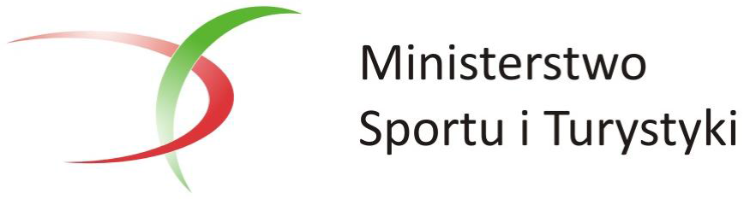

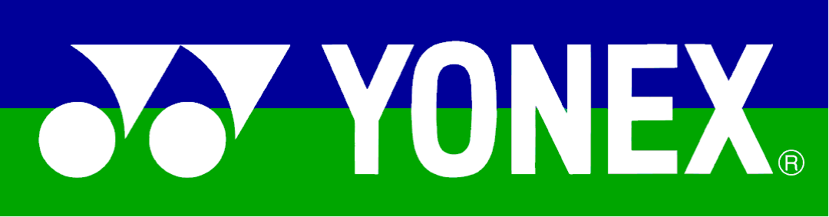
TRANSPORTATION
43rd YONEX POLISH OPEN

Warsaw, 23rd -26th March 2017

Foundation of Polish Badminton Association is responsible for the hotel transport from the Airport Warsaw Okecie – WAW to the Official Hotels and from Official Hotels to the Airport Warsaw Okecie – WAW.

Please fill up the following accommodation form:

TRANSPORTATION FORM

43rd YONEX POLISH OPEN

Warsaw, 23rd -26th March 2017

Please return this form no later than 4th March 2017 by e-mail to: polishopen@fundacjapzbad.pl

National association of:

Representatives: E-mail:

Phone number: Fax number:

1 Group
 | Arrival | Departure
Date
Time
Coming from/Going to
Flight number
Number of persons
(staff included)
Passengers name:

2 Group
 | Arrival | Departure
Date
Time
Coming from/Going to
Flight number
Number of persons
(staff included)
Passengers name:

3 Group
 | Arrival | Departure
Date
Time
Coming from/Going to
Flight number
Number of persons
(staff included)
Passengers name:

Please copy if you need

Deadline for transportation form: 4th March 2017

