**ACCOMMODATION**

**M HOTEL LJUBLJANA 4\***

OFFICAL BADMINTON HOTEL IN LJUBLJANA CITY

Perfect for sport & fun

Address:  *Derčeva ulica 4, 1000 Ljubljana, Slovenia*

Phone: 00386 1 513 7029 ; Fax: 00286 1 513 7090

[www.m-hotel.si](http://www.m-hotel.si/)

**Rates/room/  
night**

SINGLE ROOM: 68 EUR

DOUBLE OR TWIN ROOM: 90 EUR

TRIPLE ROOM: 120 EUR

The rates include accommodation with the self-service breakfast.

Suplement for the tourist tax: 1,27 EUR / person / night.

**Descritpion of**

**the hotel:** Family running hotel in Ljubljana with very friendly attitude towards their guests. Very accesiible location. They offer to the guest buffet breakfast, lunch and dinner. Nice summer terrace with bar.

**All the rooms   
have:**

free Wi-Fi Internet, air-conditioning, very comfortable mattresses from the latoflex, minibar, cable TV (lcd screens), hair dryer, phone.

Distance from M hotel to the Sport Hall Medvode: 11 km

Supplement for buffet lunch or dinner: 12 EUR

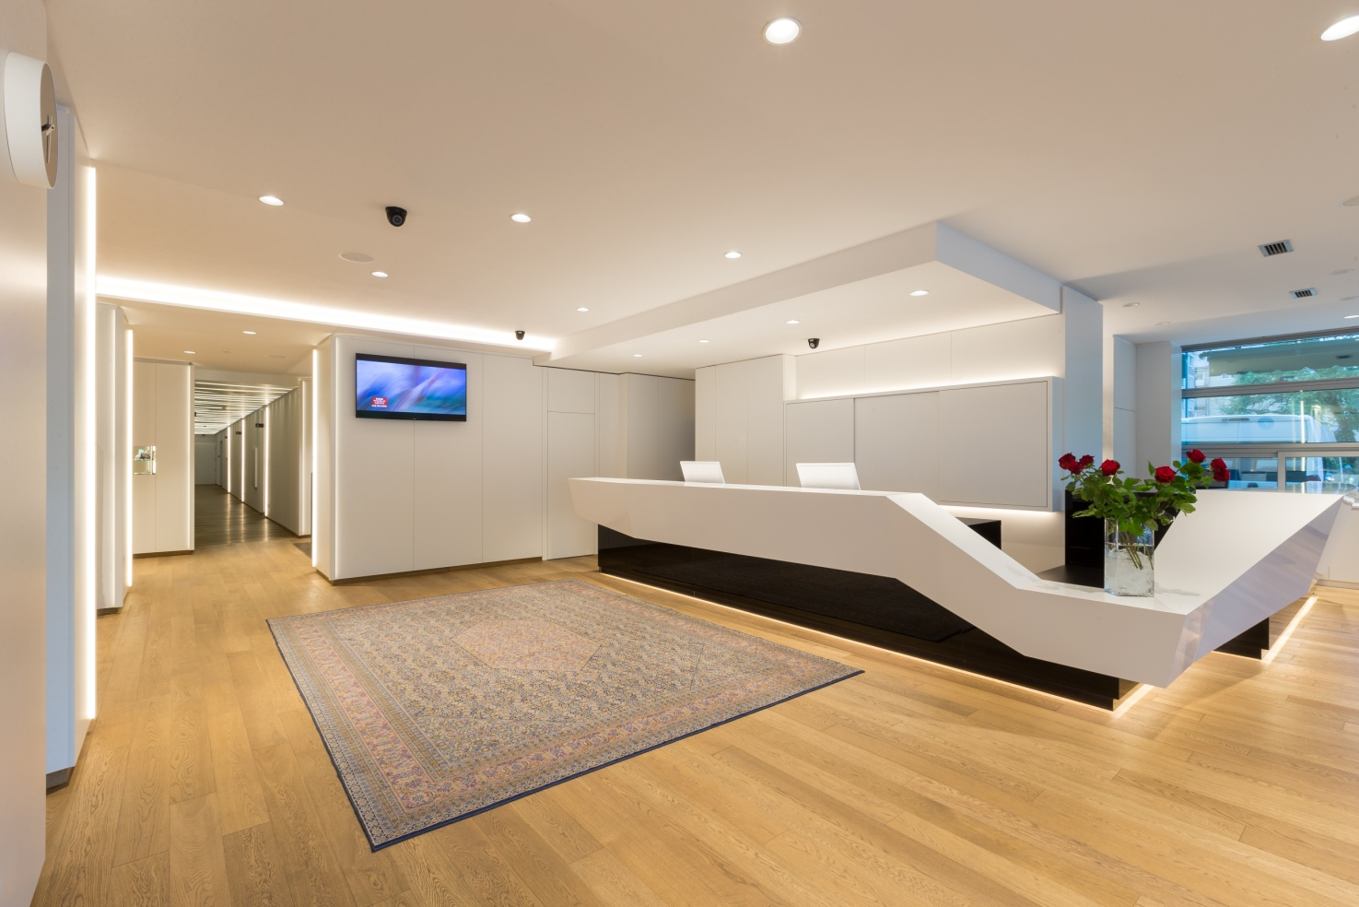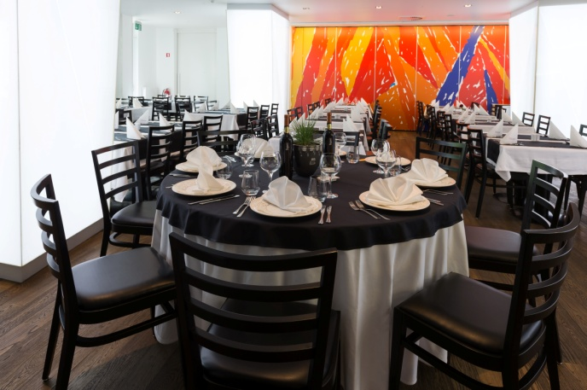

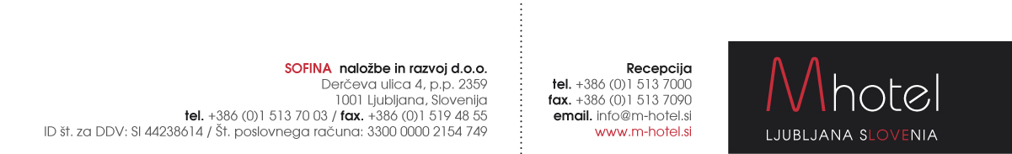

**HOTEL RESERVATION FORM**

**M HOTEL LJUBLJANA FOR Badminton 2017**

**(10.5. – 15.5. 2017)**

Reservations to be sent to the following e-mail address: [**anja.novak@m-hotel.si**](mailto:anja.novak@m-hotel.si)

|  |  |
| --- | --- |
| First and last name: |  |
| Room type and number of persons: |  |
| Arrival date: |  |
| Departure date: |  |

**Special rates:**

|  |  |
| --- | --- |
| Single Comfort room:  Double / twin room:  Triple room:  Tourist tax: | 68 EUR / night.  90 EUR / night.  120 EUR / night.  1,27 EUR / person / night. |

Payments: Payment to be made directly at the hotel.

Limited no. of the rooms are reserved.

Rich buffef lunches and dinners are available every day (12 EUR / person).

Beautiful open-air terrace, parking places. [www.m-hotel.si](http://www.m-hotel.si)

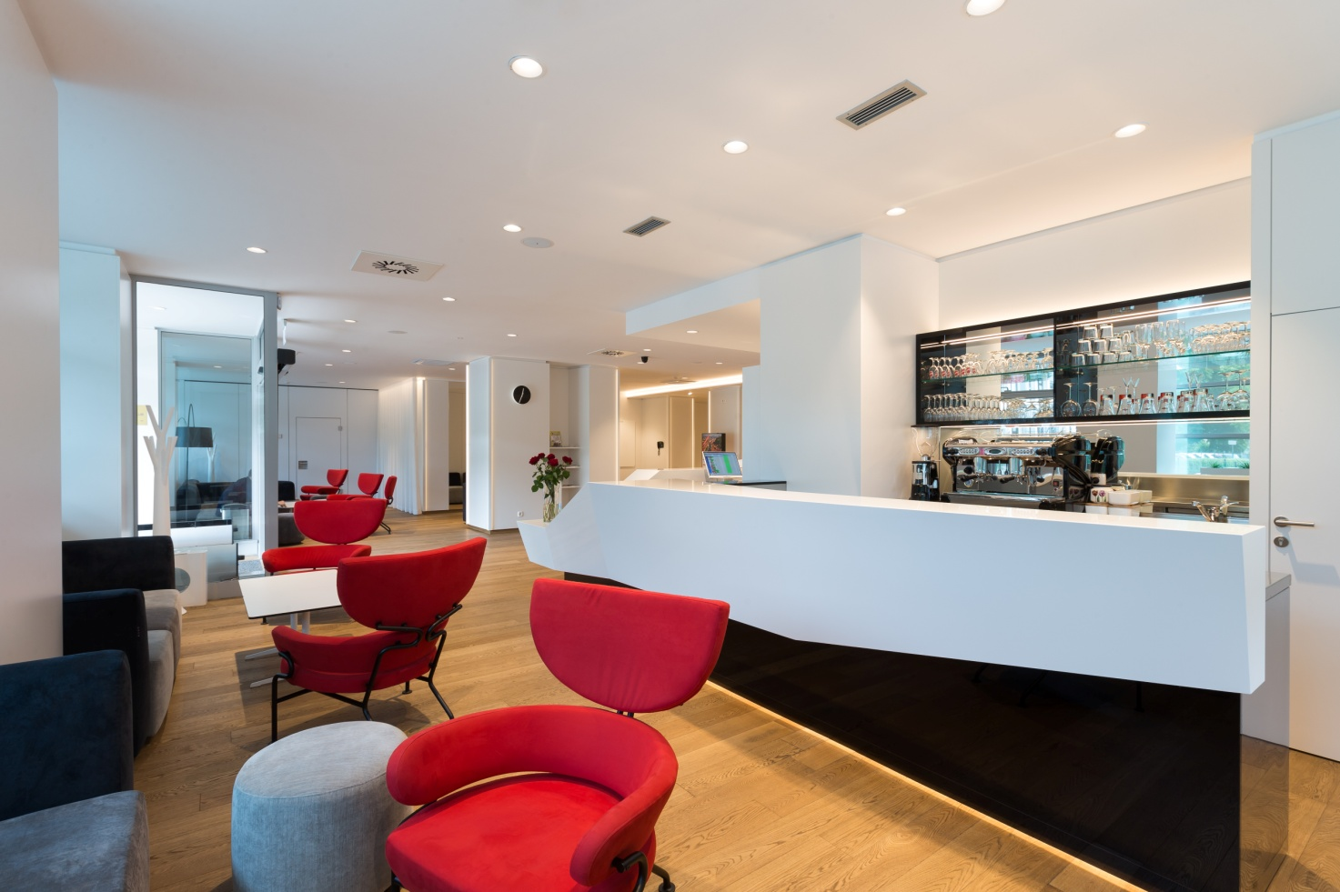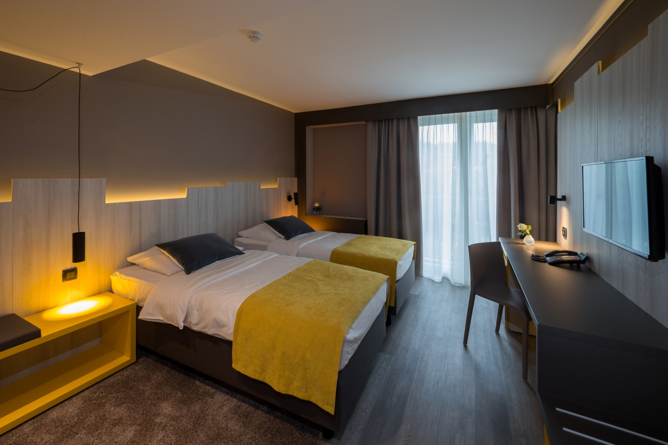

**HOTEL MEDNO**

Medno 54

1210 Ljubljana-Šentvid

Tel: 00386 1 36 26 100; Fax: 00386 1 36 26 116

[www.epiceco-hotels.com](http://www.epiceco-hotels.com)

E: [recepcija@hotel-medno.si](mailto:recepcija@hotel-medno.si)

**Rates/room/  
night**

ROOM Nr. of beds Price

Single 1 55 €

Double 2 64 €

Triple 3 90 €

The rates include accommodation with a selfservice breakfast. The tourist tax supplement is 1,27 € per person per night.

Reservations to be sent to: [recepcija@hotel-medno.si](mailto:recepcija@hotel-medno.si) with the code »Badminton«

Limited no. of rooms is blocked at the Hotel MEDNO with reservation dedline until 20th April 2016. After that date reservations are on request«.

**Descritpion of**

**the hotel:** Hotel Medno is a 3* hotel that lies on the outskirts of Ljubljana, 9 km from the city center. Hotel rooms offer a pleasant rest in green surroundings of the hotel. Hotel restaurant offers a self service breakfast, lunch and dinner.

**All the rooms   
have:**

Free Wi-Fi Internet, minibar, B+balcony, Lcd TV, telephone

The hotel offers a 50 % on wellness services to the hotel guests. (Finnish and Infra sauna, privat rooms with a massage bathtubs.

**MEDEINA d.o.o.**

**HOTEL MEDNO**

Medno 54, 1210 Ljubljana Šentvid

ID za DDV: SI50796976

tel: +386 (1) 36 26 100

IBAN: SI56 3500 1000 1243 161

fax: +386 (1) 36 26 116

SWIFT: BFKKSI22XXX

e-mail: [recepcija@hotel-medno.si](mailto:recepcija@hotel-medno.si)

web: <http://www.hotel-medno.si>

**Reservation Form**

**»BADMINTON«**

Name and surname:

E-mail:

Phone:

Arrival date:

Departure date:

Room type:

Room mates:

**Payment:**

* + on spot
  + proforma invoice
  + Hotel Medno

[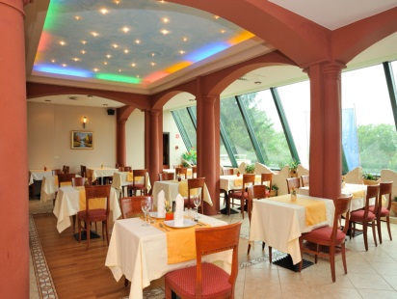](http://www.epiceco-hotels.com/images/slike/medno-restavracija.jpg)[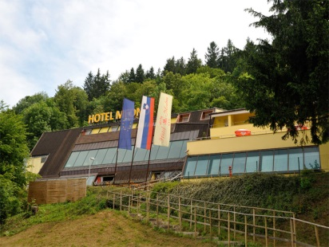](http://www.epiceco-hotels.com/images/slike/medno-hotel.jpg)[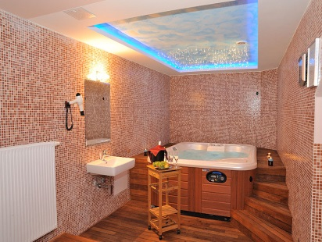](http://www.epiceco-hotels.com/images/slike/medno-sauna.jpg)