Yonex Welsh International 2017
Accommodation Booking Form

There are two official hotels available at the Yonex Welsh International 2017.
Please Note: There is an international rugby match in Cardiff on the 2nd of December and accommodation in the City Centre will be scarce.
Please take note of the booking deadlines below and ensure that you make your bookings in plenty of time.
Badminton Wales will not be responsible for any accommodation bookings should participants miss the booking deadline.

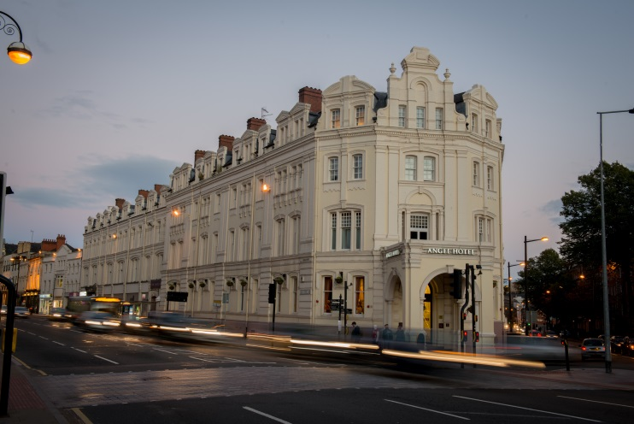 The Angel Hotel. 3*

Castle Street, Cardiff, CF10 1SZ
https://www.thecairncollection.co.uk/hotels/the-angel/

Single Room : £75.00 per room per night
Double/Twin Room : £80.00 per room per night
*These prices include bed and breakfast

- Located within Cardiff City Centre, the hotel is 1km from the venue.
- 15 Twin Rooms and 15 Double Rooms have been reserved.
- Reservations should be made directly with the hotel by the 31st October, any bookings made after this date are subject to availability.
- Special discounted rate will only be held until 7th November.
- Cancellations may be made up until 2pm on the day of arrival.
- Transport will not be provided between hotel and venue.

Bookings are to be made directly with the hotel.

To make a booking please contact reservations@angelhotelcardiffcity.co.uk or call +442920649200 and choose option 1 on the switch board.
Please quote BAMD281117 upon booking to receive the discounted rate.

Rooms will be allocated on a first come first serve basis.

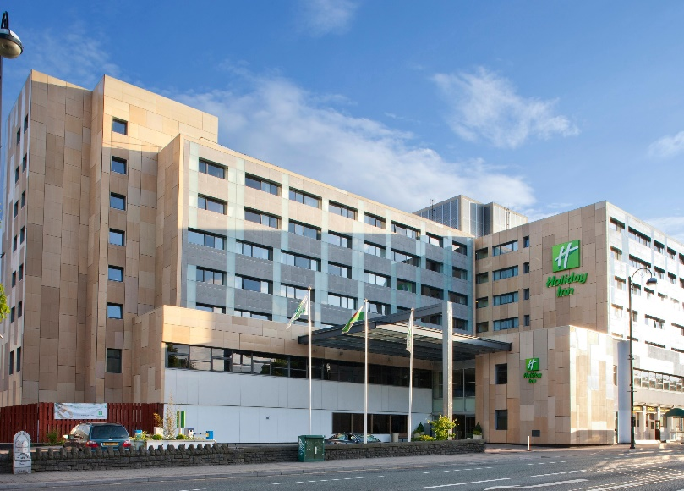 Holiday Inn
Cardiff City Centre 3*
Castle Street, Cardiff, CF10 1XD
https://www.ihg.com/holidayinn/hotels/gb/en/cardiff/cdfcy/hoteldetail

Prices:
27th – 30th November: Single £75.00 Double £85.00
1st and 2nd December: Single £100.00 Double £110.00
* These prices include bed and breakfast

- Located within the City Centre, the hotel is 1km from the venue.
- Reservations should be made by the 3rd of November, any bookings made after this date are subject to availability and may not be at the discounted rate.
- Any room cancellations made after the 3rd of November are subject to the full booking fee minus any discounted rate offered.
- Payment to be made to Badminton Wales
- Transport will not be provided between hotel and venue.

Please complete and return this form to Carissa.Turner@badminton.wales by Friday the 3rd of November.
Cheques/Bankers Drafts in pounds sterling, should be made payable to Welsh Badminton Union Ltd
Online payments to be made by Friday 10th November to:
Acc No. 02 52 91 77
Sort Code 30-96-91
Lloyds TSB. Queen Street, Cardiff.
IBAN: GB04 LOYD 3096 9102 5291 77
SWIFT/BIC: LOYDGB 21217

Requests to pay at the tournament will be granted at Badminton Wales’s discretion.
Please note that should BW receive payment which has incurred a charge and therefore doesn’t cover the full cost, BW will invoice for the difference or ask the players for the remainder of the amount at the tournament. This should be paid prior to the players first match.

HOLIDAY INN RESERVATION FORM

National Association
Contact Person
Mobile phone
Email address

Room Type | Name(s) per room | Arrival Date | Departure Date

