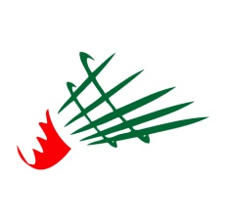

Fédération Algérienne de Badminton

Algeria Junior International
Algiers, Algeria - 14th to 16th November 2017

AIRPORT TRANSFER FORM

Send this form by email to badalgerie@gmail.com

- Transport booking must be done after confirmation of your tournament registration

- In order to ensure a good transport service fill in all information requested below

Thank you for your understanding !!!

Association name |  | Contact Name
Mobile phone |  | Email address

Arrival
Name | Surname | Airport  (ALG/DZ) | From | Date | Time | Flight  number | Phone number | email

Departure
Name | Surname | Airport  (ALG/DZ) | From | Date | Time | Flight  number | Phone number | email

Transport Houari Boumédiéne Airport [O]
11th Nov /12th Nov /13th Nov | FREE OF CHARGE
16th Nov /17th Nov /18th Nov | FREE OF CHARGE

