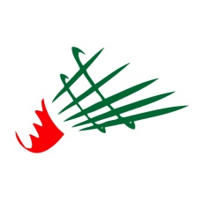
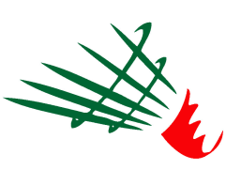

Fédération Algérienne de Badminton

Algeria Junior International
Algiers, Algeria - 14th to 16th November 2017

PRACTICE COURT RESERVATION FORM
Send this form by email to badalgerie@gmail.com

(PLEASE PRINT IN BLOCK CAPITALS)

National Association of
Name of Contact
Mobile phone
Email address

Sunday 12th to Monday 13 ^{th} (Practice court )

Date | 10am | 12am | 2pm | 4pm | 6pm | 8pm
Sunday
Monday
Put the number of player in the any cells

Tuesday 14th 2016 (Main court)

 | 6pm | 7pm | 8pm | 9pm
Court 1
Court 2
Court 3
Court 4
Court 5
Put the number of player in the any cells

