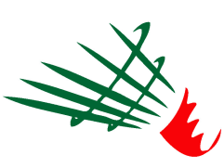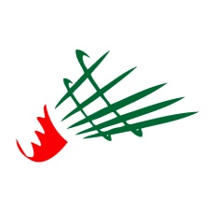

**Fédération Algérienne de Badminton**

**Algeria Junior International**

Algiers, Algeria - 14th to 16th November 2017

#### VISA APPLICATION FORM

**Send this form by email to badalgerie@gmail.com**

|  |  |
| --- | --- |
| National Association of |  |
| Name of Contact |  |
| Mobile phone |  |
| Email address |  |

|  |  |  |  |  |  |  |  |
| --- | --- | --- | --- | --- | --- | --- | --- |
| **GIVEN NAME** | **FAMILY NAME** | **GENDER** | **DATE OF BIRTH**  **(dd/mm/yyyy)** | **NATIONALITY** | **PASSPORT NUMBER** | **EXPIRY DATE**  **(dd/mm/yyyy)** | **FUNCTION** |
|  |  |  |  |  |  |  |  |
|  |  |  |  |  |  |  |  |
|  |  |  |  |  |  |  |  |
|  |  |  |  |  |  |  |  |
|  |  |  |  |  |  |  |  |
|  |  |  |  |  |  |  |  |
|  |  |  |  |  |  |  |  |
|  |  |  |  |  |  |  |  |
|  |  |  |  |  |  |  |  |
|  |  |  |  |  |  |  |  |
|  |  |  |  |  |  |  |  |