Orléans International Challenge
Orléans, France - march 31th to april 3th 2016

HOTEL BOOKING FORM

- Booking by e-mail to each hotel – see next page

- No later than friday, March 11th

- Payment at the hotel

- Shuttles tournament will serve only officials hotels

- Inform the hotel that you are registered for the tournament, thank you!!

Officials Hotels
Hotel | Location | Week  (Monday to Thursday) | Week-end  (Friday to Sunday) | Breakfast | Fee¹
Ibis Centre Foch (3*) | 15 minutes walking | 91€ | 40€ | 9,5€ | 1,10€
Ibis Station (3*) | To beside a station | 91€ | 40€ | 9,5€ | 1,10€
¹ Fee per night and per person.
All prices mentioned above per room per day.

ACCOMMODATION RESERVATION FORM
National Association of
Name of person who booked
Mobile phone
Email address

Names of people who stay
Name of Passengers | 1- | 6-
 | 2- | 7-
 | 3- | 8-
 | 4- | 9-
 | 5- | 10-

Officials Hotels
Hotel | Arrival Date | Departure Date | Breakfeast
Ibis Centre Foch (3*)
Ibis Station (3*)

Date : | Signed :
Send this form to directly to hotel of your choice with the payement (see below for the mail and phone)

IBIS Station - 15 avenue de Paris 45000 Orléans
Phone +33 2 38 62 40 40
Fax +33 2 38 77 13 59
Mail h0862@accor.com
Website www.ibishotel.com

IBIS Foch - 4 rue du Marechal Foch 45000 Orléans
Phone +33 2 38 54 23 11
Fax +33 2 38 62 19 00
Mail h1397@accor.com
Website www.ibishotel.com

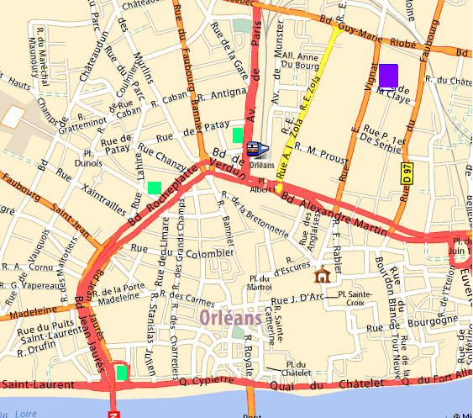
Hôtels
IBIS Station
IBIS Foch
Venue

Orléans International Challenge
Orléans, France - march 31th to april 3th 2016

PRACTICE COURT RESERVATION FORM
Send this form by email to entries@cltobadminton.fr

(PLEASE PRINT IN BLOCK CAPITALS)

National Association of
Name of Contact
Mobile phone
Email address

Monday march 28th to Wednesday march 30th (= Practice court )

Date | 10am | 12am | 2pm | 4pm | 6pm | 8pm
Monday
Tuesday
Wednesday
Put the number of player in the any cells

Wednesday march 30th 2016 (= Main court)

 | 6pm | 7pm | 8pm | 9pm
Court 1
Court 2
Court 3
Court 4
Court 5
Put the number of player in the any cells

Orléans International Challenge
Orléans, France - march 31th to april 3th 2016

VISA APPLICATION FORM
Send this form by email to entries@cltobadminton.fr

National Association of
Name of Contact
Mobile phone
Email address

GIVEN NAME | FAMILY NAME | GENDER | DATE OF BIRTH  (dd/mm/yyyy) | NATIONALITY | PASSPORT NUMBER | EXPIRY DATE  (dd/mm/yyyy) | FUNCTION

Orléans International Challenge
Orléans, France - 31th march to 3th april 2016

AIRPORT TRANSPORT SERVICE

Send this form by email to entries@cltobadminton.fr

- Transport booking must be done after confirmation of your tournament registration

- In order to ensure a good transport service fill in all information requested below

- The tournament entry will be easier if you have paid in advance

Thank you for your understanding !!!

Association name |  | Contact Name
Mobile phone |  | Email address

Arrival
Name | Surname | Airport  (ORY/CDG) | From | Date | Time | Flight  number | Phone number | email

Departure
Name | Surname | Airport  (ORY/CDG) | From | Date | Time | Flight  number | Phone number | email

Transport Orly Airport [ORY]
28th march /29th march /30th march | 40 euro/trip/person
Wednesday march 30th to Sunday april 3th | FREE OF CHARGE
Transport Roissy Airport [CDG]
Monday, march 28th to Monday, april 4th | 50 euro/trip/person

