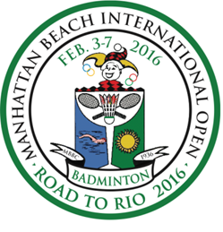
TRANSPORTATION REQUEST FORM
Main contact person |  | Yuko Kawasaki
Email Address |  | mbbctournament@yahoo.com
Complete this transport request form and sent back to: mbbctournament@yahoo.com
by January 15, 2016. Late requests will not be accepted.
Airport transportation to and from the hotel will only be arranged for players, coaches, and officials staying at the official tournament hotel for a fee of $30 (roundtrip). Anyone using this transportation can make payment for this service when first arriving at the venue.
TEAM
ARRIVAL
NUMBER OF PASSENGERS
DATE OF ARRIVAL
EXPECTED ARRIVAL TIME
FLIGHT NUMBER:
AIRPORT DEPARTING FROM
TERMINAL NUMBER
DEPARTURE
NUMBER OF PASSENGERS
DATE OF DEPARTURE
EXPECTED DEPARTURE TIME
FLIGHT NUMBER
TERMINAL NUMBER
Name of Team Manager
Phone Contact
Manager Signature
Date

