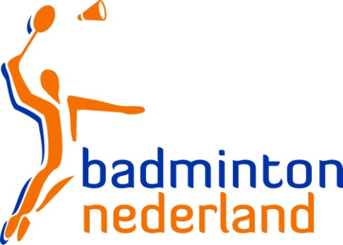

Yonex Dutch Junior International 2016

Junior Grand Prix Tournament

ACCOMMODATION FORM

TO: Yonex Dutch Junior International Tournament Committee
c/o Mrs. Thilini Scherpenzeel Phone: +31-620591433
Warmoesstraat 30, 2011HP Email: tournament@dutchjunior.com
Haarlem, The Netherlands

National Association of:
Representative:
Phone Number: | Fax Number:
E-mail address:

The Tournament Committee has options on the following accommodation. All prices in Euros for Bed & Breakfast.3 Tourist Tax excluded.

Hotel | 3 pers. room  economy | 2 pers. room  economy | 1 pers. room  economy | 2 pers. room  comfort | 1 pers. room  comfort | p.p.p. night
Hotel Haarlem-Zuid | € 139,00 | € 109,00 | € 93,00 | € 120,00 | € 103,00
Youth Hostel Stay Okay | - | - | - | - | - | € 32,00

Our Association makes the following reservation:

Hotel | 3 pers. room  economy | 2 pers. room  economy | 1 pers. room  economy | 2 pers. room  comfort | 1 pers. room  comfort | Arrival  date | Departure date
Hotel Haarlem-Zuid

Hotel | Number of female players | Number of male players | Number of female coaches | Number of male coaches | Arrival date | Departure date
Youth Hostel Stay Okay

Date: Signature:

>>>> SUBMIT BEFORE 10 February 2016 <<<<

