SINGAPORE INTERNATIONAL
SERIES 2016
OUE

OFFICIAL INVITATION

30 AUGUST– 3 SEPTEMBER 2016

Singapore Badminton Hall

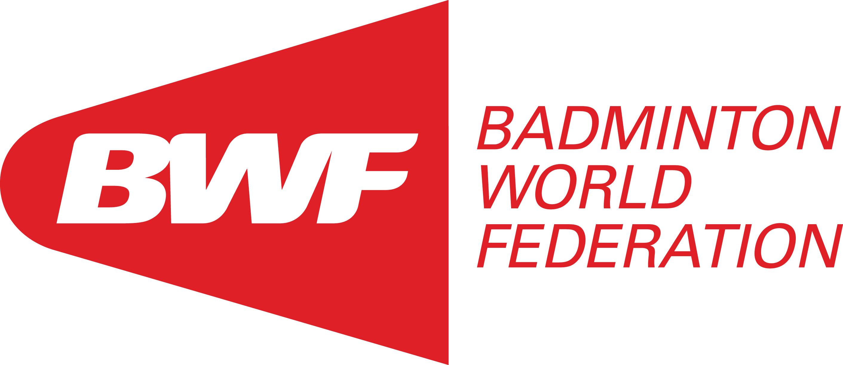


ORGANISER SUPPORTED BY
Singapore Badminton Association Sport Singapore 

ADDRESS:
5 Stadium Drive, #02-40, OCBC Arena Singapore 397631
Phone : +65 – 6344 1773
Facsimile : +65 – 670223890
Email : secretariat@singaporebadminton.org.sg, chris@singaporebadminton.org.sg

Website : http://www.singaporebadminton.org.sg

SANCTIONED BY
Badminton World Federation (BWF) & Badminton Asia

VENUE
Singapore Badminton Hall
No. 1 Lorong 23 Geylang
Singapore 388352

CHAMPIONSHIP DATES
Day 1 Tuesday, 30th Aug Qualifying / Preliminary Rounds
Day 2 Wednesday, 31st Aug Preliminary Rounds
Day 3 Thursday, 1st Sep Preliminary Rounds
Day 4 Friday, 2nd Sep Quarter-Finals / Semi-Finals
Day 5 Saturday, 3rd Sep Finals

Note: The schedule is subject to confirmation by the Referee.

REFEREES
Referee : Kieu Khuyen (VIE)
Email : kieukhuyen2002@yahoo.com

Deputy Referee : Phillip Lee
Email : PhillipLee52@gmail.com

PRIZE MONEY
- Total US$6,000
- Medals for all winners and runner-up.
- Distribution of prize money shall be as follows:
S/N | Event | Champion | Runner Up | Semi-Finalists (each)
1 | Men’s Singles | 540 | 240 | 120
2 | Women’s Singles | 540 | 240 | 120
3 | Men’s Doubles | 720 | 312 | 144
4 | Women’s Doubles | 720 | 312 | 144
5 | Mixed Doubles | 720 | 312 | 144

Note: The above figure is in US dollar. Prize winners will be paid in Singapore dollar based on the exchange rate at that point of time.

EVENTS
Event | Entries
Event | Main Draw | Qualifiers | Number of Entries – Qualifying Draw
Men’s Singles | 48 | 16 | 64
Women’s Singles | 24 | 8 | 32
Men’s Doubles | 24 | 8 | 32
Women’s Doubles | 24 | 8 | 32
Mixed Doubles | 24 | 8 | 32

- All entries must be submitted through their national associations.
- All entries must be submitted online using the following link: http://bwf.tournamentsoftware.com/sport/tournament.aspx?id=C035474A-E045-48BE-B358-31A78425C83E
- Entries close on 2 August 2016 (Tuesday). Late and incomplete entries will be rejected.
- Player(s) without BWF ID numbers are to contact your National Association.
- National Associations will be notified whether their players have been accepted directly into the Main Draw or if they are required to play in the qualifying rounds once entries are evaluated after the closing date. The information will be published and updated on the website: http://badmintonasia.org/tournaments/badminton-asia-event-calendars/singapore-international-series-2016

- You will require a username and password to submit your entries and this can be obtained from the BWF: please contact Mr. Shan at s.ramachandran@bwfbadminton.org . The online entry page will close immediately on the entries closing date at 23:59 hours BWF Headquarters time (+08:00h GMT) and you are required to submit the entries on time. Late entries will not be accepted.
- National Associations are reminded to appoint ONE team manager per country to facilitate communication.
- 6 courts will be used for this event.

CONDITIONS FOR ENTRIES
- The organiser will NOT be responsible for any injury sustained, at any time, by any player or official arising from his participation in this Championships. Any costs incurred for medical treatment and / or hospitalisation shall be borne by the Member Association of the player / official concerned.
- Costs of medical treatment and hospitalisation in Singapore are high. Adequate medical insurance coverage for your players / officials is necessary.
- Certificate of medical insurance coverage / full payment is required before medical treatment / hospitalisation takes place.

RULES & REGULATIONS
- The Competition shall be played in accordance with the Laws of Badminton and shall comply with the BWF General Competition Regulations (GCR).
- No player shall be eligible to compete unless he / she is :-
Under the jurisdiction of a Member Association of the Federation
Has been declared in good standing with that Member Association
- The Organisers reserve the right to decide on the numbers of entries admitted into the qualifying rounds.
- Seeding and draws will be conducted by Badminton Asia:
  - Ranking for M&Q, Qualifying Draw Seeding Promotions:4 August 2016
  - Published M&Q Report: 5 August 2016
  - Ranking for Main Draw Seeding and Draw: 11 August 2016
  - Published Seeding Report: 12 August 2016
  - Draw: 16th August 2016
- Alteration of the competition schedule due to unforeseen circumstances may arise and will be announced by the Referee accordingly.
- Scoring System: The rally point scoring system shall be used (3X21pts).
- Withdrawal: Notification of withdrawal(s) with reason must be given immediately to the Tournament Secretary by fax or email. Withdrawal(s) made after 14th August 2016 due to injury or illness must be supported by a medical certificate. Any withdrawal after the Sunday immediately preceding the draw for any reason whatsoever, renders to Member Association concerned liable to an amount US$150 per player / pair to the BWF.
- Li-Ning A+ 300 shuttlecocks will be used.

CLOTHING / ADVERTISING
Advertising on clothing and colour of clothing shall be regulated by General Competition Regulations 19 to 23. In particular, the following shall be noted;

- The name of the player on the back of the shirt is mandatory.
- The name of the player’s country on the back of the shirt is optional.
- It is recommended for doubles partners to wear the same colour from the quarter-finals onwards.
- It is recommended that, from the quarter-finals onwards, the opposing player/pair in each match wear different colors from each other.
- Lettering shall be in capital letters in the Roman alphabet and shall be placed, as close to horizontal as possible, near the top of the shirt. Lettering must be a minimum height of 6 centimeters and a maximum height of 10 centimeters.
- Lettering sequence on the shirt from top to bottom shall be player name, country name (5cm if present) and advertisement (not exceeding 5 cm if present).

IMPORTANT MEETINGS
Type of Meeting | Date / Time | Venue
Team Managers’ Meeting | Monday, 29 August 2016  (1730hrs) | Singapore Badminton Hall Address: 1 Lorong 23 Geylang, Singapore 388352
Umpires’ Briefing | Monday, 29 August 2016  (1900hrs)

Note: The meeting dates/times are tentative.
Note: As per BWF Regulations, the Team must be represented in the Managers’ Briefing.
"It is compulsory that all team managers must attend the team managers meeting .Failing to attend the meeting they are liable to be fined as per regulation Part III Section 1B, Appendix 11 “Offences and Penalties” .Member Associations can make a request someone to represent them at the meeting as long as the Referee knows in advance that is acceptable"

PRACTICE COURTS
- Practice courts will only be available at the competition venue on Monday, 29TH August 2016. The Organising Committee will prepare an overall equitable practice schedule, taking into consideration the size of each team and priority on a first-come-first-served request basis.
- No shuttlecocks will be provided for practice.
- More courts can be booked at the hall adjacent to the competition venue at team’s own cost.

PRESS INTERVIEWS
Players must attend press interviews immediately after their respective matches and any other requested time (e.g. press conference, training session, etc) whenever necessary.

VISA
The Singapore Immigration and Checkpoints Authority has implemented various measures to facilitate visa applications for entry to Singapore. For updated information, you may refer to the website: www.ica.gov.sg to check if visa is required for your respective countries. (Refer to Appendix A for Visa Application Form)

ACCOMMODATION
Official Hotel | Room Type | Rates
Fragrance Hotel – Ruby  10 Lorong 20 Geylang, 398730  DID: +65 6508 0851 (Daniel Khor)  Reservation Hotline: +65 6345 6116 | Twin Sharing | S$82 nett per room per night  Breakfast: S$10nett per person (Optional)  Internet access

Fragrance Hotel – Pearl  21 Lorong 14 Geylang, 398961  DID: +65 6508 0851 (Daniel Khor) | Twin Sharing | S$82 nett per room per night  Breakfast: S$10nett per person (Optional)  Internet access

- Prize above are all in Singapore Dollars
- All room reservations are to be done via the hotel reservation forms.
- Note: Kindly make your reservations early to avoid non-availability of rooms.

- Any correspondences with the hotel must be sent directly to the hotel sales team at Daniel Khor danielkhor@gphl.com.sg or booking@gphl.com.sg and copied to the Organisers at secretariat@singaporebadminton.org.sg.

- Please kindly state the event code OUE2016 when making reservation for the hotel.

- The cutoff date for all room reservations have to be made 7 days prior to arrival date or otherwise a one night room charge per room booked will be imposed. In the event of no show or shortened stay, a charge equivalent to one room night charge per room booked will be imposed.

- Guest will have to make full payment before arrival by credit card by filling the credit card form provided.

- For Tele- Transfer payment, customer is responsible for all Local and Overseas Bank transaction charges and 7 days before arrival date. Kindly make the payment to Fragrance Hotel Management Pte Ltd.

- SBA can refer BAs to other hotels that suit its purposes better. Please email to
secretariat@singaporebadminton.org.sg for more information.

- Fragrance Hotel (Ruby) is the Official Hotel for the Event. The Hotel Secretariat Services will only be available at Fragrance Hotel (Ruby).
- The official hotel Fragrance Hotel Ruby (Appendix B) is approximately 5 Minutes by foot from the competition venue & Fragrance Hotel Pearl( Appendix C) 7 Minutes by foot

Transport from Airport

For transportation you may book at the following website to the official hotel: http://www.limousinecab.com/rates/ or alternatively you may book a cab from the airport at different terminals. Below are the rates for the maxi cab. (No Claims will be Refunded)

 |  | 4-seater | 6-seater | 13-seater
 |  | (flat rates) | (flat rates) | (flat rates)
Arrival Transfer (Per Way) |  | SGD 60 | SGD 65 | SGD 80
Departure Transfer (Per Way) |  | SGD 50 | SGD 55 | SGD 70
Rates are subjected to change

Train
It is also possible to reach the official hotel by train. The Changi Airport MRT Station is located at the basement of Terminals 2 and 3. It is accessible from the Arrival and Departure Halls of these two terminals and there are escalators and lifts to connect you to the station entrance. You may ask for assistance from the service staff at the train station. The nearest train station to the official hotel is Aljunied train station which is approximately 15 mins walk to the hotel.

-End-

Appendix A: VISA APPLICATION FORM

Badminton Association:
Contact person:
Contact Number: |  | Email:
Mobile Phone : |  | Email:

Last Name: |  | Passport no.:
First Name: |  | Issue/expiry date:
Date of Birth: |  | Occupation:
Nationality: |  | Sex:

Last Name: |  | Passport no.:
First Name: |  | Issue/expiry date:
Date of Birth: |  | Occupation:
Nationality: |  | Sex:

Last Name: |  | Passport no.:
First Name: |  | Issue/expiry date:
Date of Birth: |  | Occupation:
Nationality: |  | Sex:

Last Name: |  | Passport no.:
First Name: |  | Issue/expiry date:
Date of Birth: |  | Occupation:
Nationality: |  | Sex:

Last Name: |  | Passport no.:
First Name: |  | Issue/expiry date:
Date of Birth: |  | Occupation:
Nationality: |  | Sex:

Last Name: |  | Passport no.:
First Name: |  | Issue/expiry date:
Date of Birth: |  | Occupation:
Nationality: |  | Sex:

Last Name: |  | Passport no.:
First Name: |  | Issue/expiry date:
Date of Birth: |  | Occupation:
Nationality: |  | Sex:

Last Name: |  | Passport no.:
First Name: |  | Issue/expiry date:
Date of Birth: |  | Occupation:
Nationality: |  | Sex:

Last Name: |  | Passport no.:
First Name: |  | Issue/expiry date:
Date of Birth: |  | Occupation:
Nationality: |  | Sex:

Last Name: |  | Passport no.:
First Name: |  | Issue/expiry date:
Date of Birth: |  | Occupation:
Nationality: |  | Sex:

Last Name: |  | Passport no.:
First Name: |  | Issue/expiry date:
Date of Birth: |  | Occupation:
Nationality: |  | Sex:

Appendix B (Fragrance Hotel Ruby, Official Hotel)
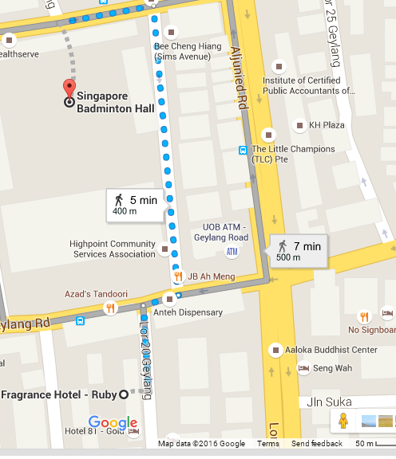

Appendix C (Fragrance Hotel Pearl to Singapore Badminton Hall)



