Closing date for bookings 30/08/2016

To send to belgianjunior@lfbb.be

BEST WESTERN POST Hotel Sportcenter Blegny Mine
Rue Hurbise 160, 4040 Herstal Rue Belle Fleur 3, 4670 Blegny
www.bestwestern.be/posthotel
Only 40 rooms are available Only 15 rooms are available

Single room: 80,00€ Single room: 39,00€ per person/per night
Twin room: 100,00€ per room / per night Twin room: 24,50€ per person/per night
Triple room: 110,00€ per room/night (only 2) Triple room: 59,00€/room/night (only 4)
Wellness Center and buffet breakfast are included Breakfast 5,50€/person/breakfast

Local transport Local transport
provided by the organizer between the There is no transport from this accommodation
official hotel and the venue (3.5km) to the venue (16km)

National association:

Phone and fax number:

Responsible person:

E-mail address:

Best Western Sportcenter Blegny Mine _______________________________________________________________________
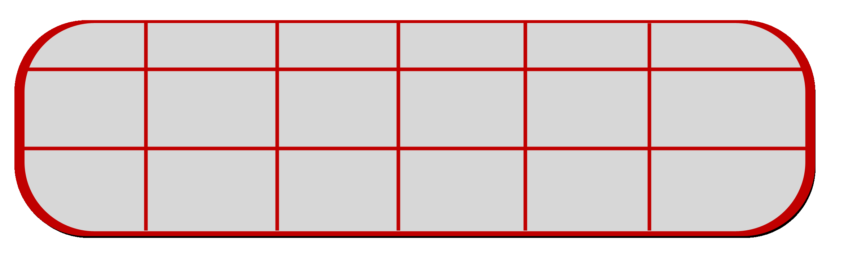

Wednesday Thursday Friday Saturday Sunday
Night of 21/09/16 22/09/16 23/09/16 24/09/16 25/09/16

Number of
twin rooms

Number of
single rooms

we accept sharing the room with other players in the tournament

Closing date for bookings 30/08/2016

To send to belgianjunior@lfbb.be

Lunch – Fixed price of 10€
Dinner – Fixed price of 10€

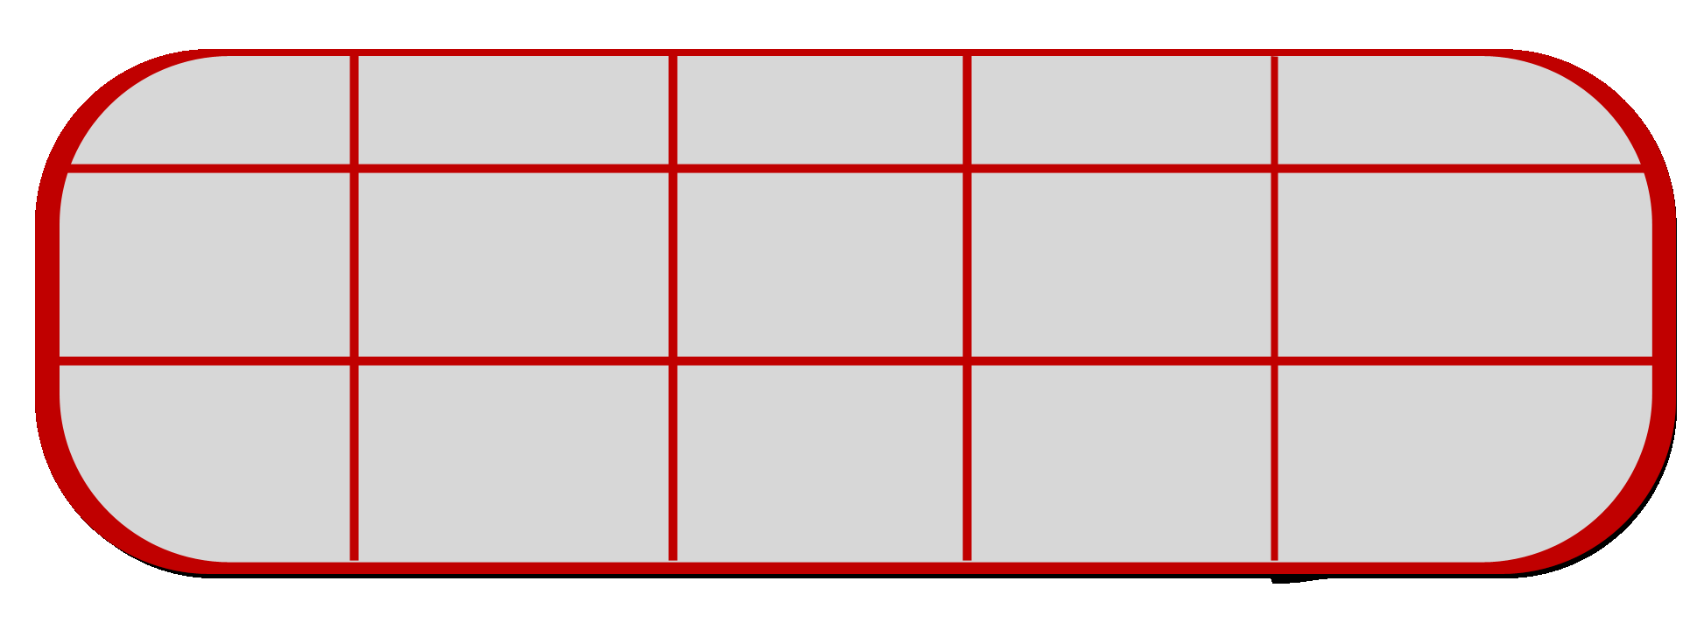

Thursday Friday Saturday Sunday
Number of 22/09/16 23/09/16 24/09/16 25/09/16

Lunch

Dinner

All meals need to be ordered before the tournament.

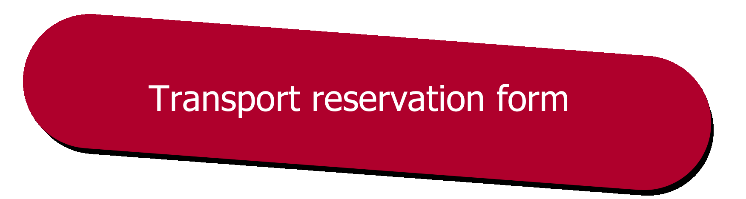

Closing date for bookings 10/09/2016

To send to belgianjunior@lfbb.be

National association:

Phone and fax number:

Responsible person:

E-mail address:

Means of transport:

(By car, by train, by plane, others...)

_

_______________________________________________________________________
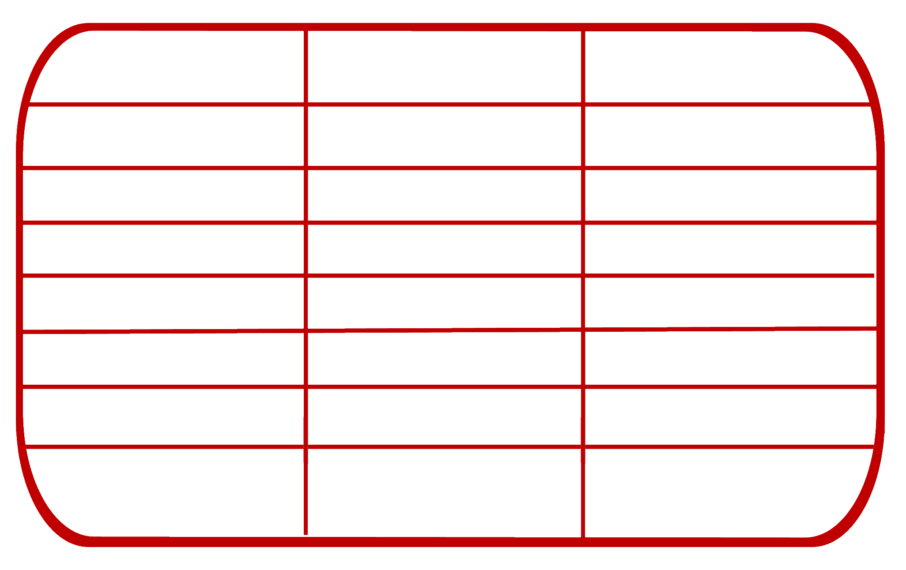
Departure Arrival

Date

Airport/Train station
Time

Number of persons (staff incl.)

Flight Number

Train Number

Coming From / Going To

Date Signature

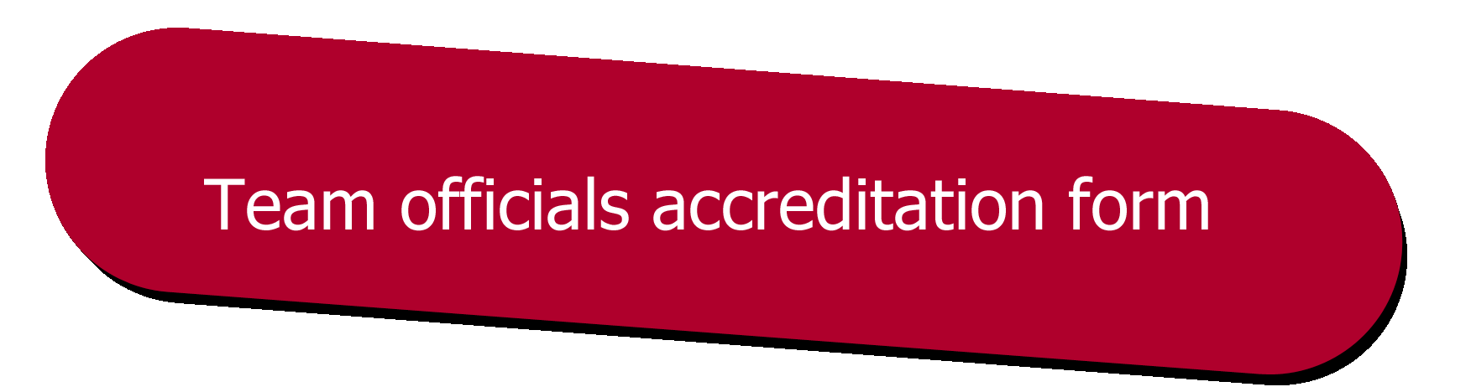

Please return this form to:

Belgian Badminton Federation
E-mail: belgianjunior@lfbb.be

Team:

Team Manager:

Contact Phone Number :

The following officials will be accompanying the players:
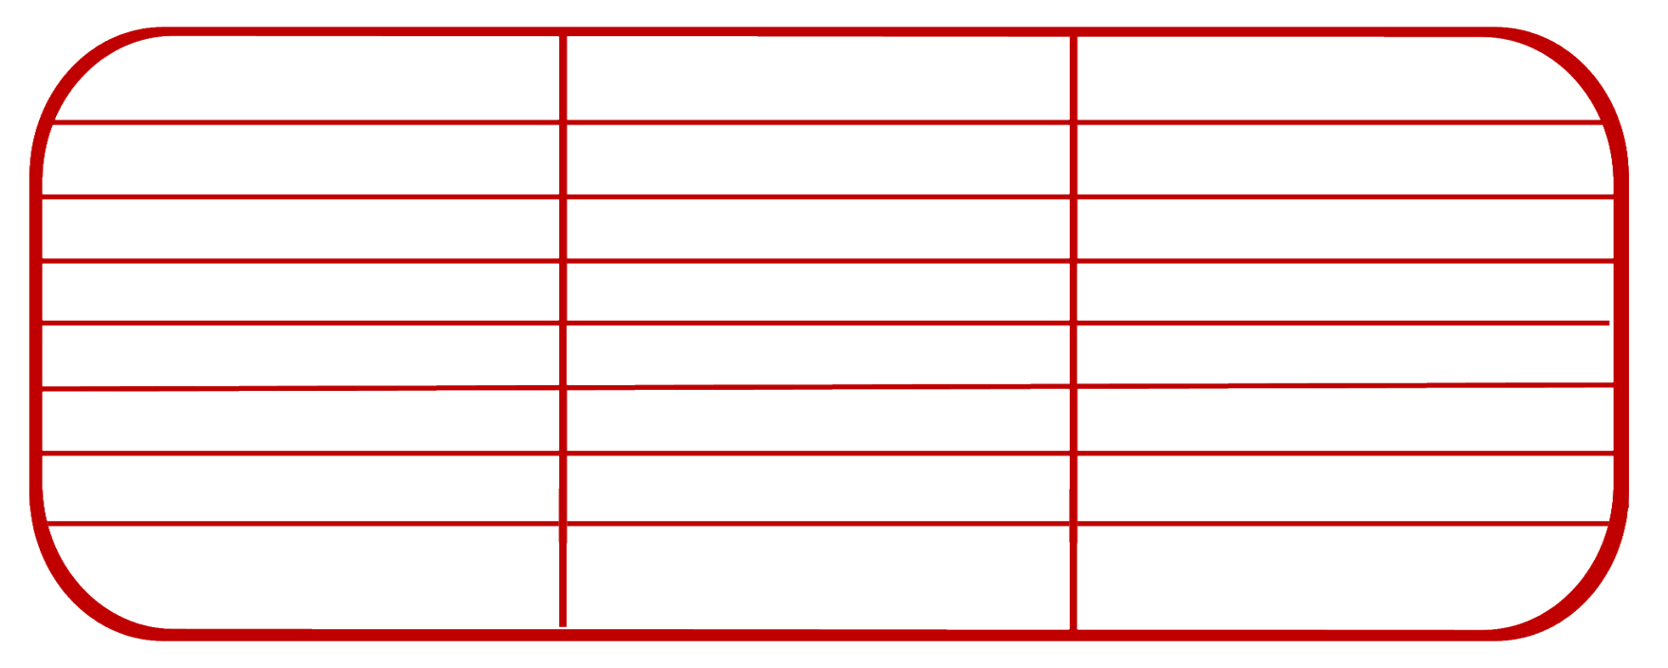
FULL NAME OFFICIAL POSITION PHONE NUMBER

2.

3.

4.

5.

6.

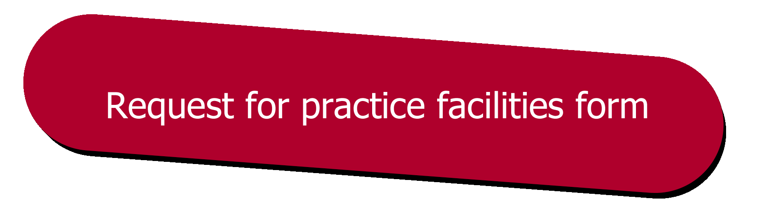

Please return this form to:

Belgian Badminton Federation
E-mail: belgianjunior@lfbb.be

Team:

Team Manager:

Contact Phone Number :

Thursday 22 September 2016
17u – 18u 18u – 19u 19u – 20u

Court 1.

Court 2.

Court 3.

Court 4.

Court 5.

Court 6.

The practice courts are situated in the main hall.

