Welsh International 2016
Accommodation Booking Form

Please complete and return this form to Carissa.Turner@badminton.wales by Friday the 4th of November.
Cheques/Bankers Drafts in pounds sterling, should be made payable to Welsh Badminton Union Ltd
Online payments to be made by Friday November 11th to:
Acc No. 02 52 91 77
Sort Code 30-96-91
Lloyds TSB. Queen Street, Cardiff.
IBAN: GB04 LOYD 3096 9102 5291 77
SWIFT/BIC: LOYDGB 21217

Requests to pay at the tournament will be granted at Badminton Wales’s discretion.
Please note that should BW receive payment which has incurred a charge and therefore doesn’t cover the full cost, BW will invoice for the difference or ask the players for the remainder of the amount at the tournament. This should be paid prior to the players first match.

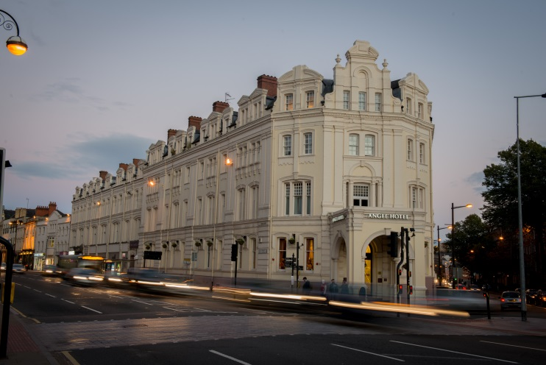 The Angel Hotel. 3*

Castle Street, Cardiff, South Glamorgan, CF10 1SZ
https://www.thehotelcollection.co.uk/hotels/cardiff-angel-hotel

Single Room : £65.00 per room per night
Double/Twin Room : £75.00 per room per night
*These prices include bed and breakfast

- Located within Cardiff City Centre, the hotel is 1km from the venue.
- 2 course dinner meals can be provided for £18.00 per person (booking in advance, booking form below)
- Reservations should be made by the 4th of November, any bookings made after this date are subject to availability.
- Any room cancellations made after Tuesday the 8th of November are subject to charge
- Payment to be made to Badminton Wales
- Transport will not be provided between hotel and venue.

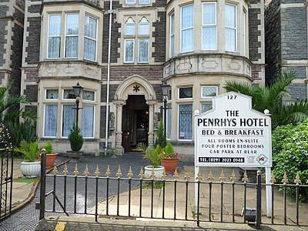 Penrhys Hotel. 3*
127 Cathedral Road, Cardiff, South Glamorgan, CF11 9PJ
http://penrhyshotel.com/

Room availability at this hotel is limited.
Price per person per night: £35.00
3 Double Rooms – one double bed
3 Twin Rooms – two beds
7 Triple Rooms – double bed and single bed
* These prices include bed and breakfast

- Located a 10minute walk from the City Centre, the hotel is 500m from the venue.
- Reservations should be made by the 4th of November, any bookings made after this date are subject to availability.
- Any room cancellations made after Tuesday the 8th of November are subject to charge
- Payment to be made to Badminton Wales
- Transport will not be provided between hotel and venue.

ACCOMMODATION RESERVATION FORM

National Association
Name of person who booked
Mobile phone
Email address

Hotel | Room Type | Name(s) | Arrival Date | Departure Date

Angel Hotel Meal Booking Form

The hotel offers a special rate of £18.00 for a 2 course dinner each evening for Welsh International Guests.
The menu will alter each evening but had a variety of meals on offer.
Please make a note if you have any special dietary requirements.

Date | No. of People
Tuesday 29th November
Wednesday 30th November
Thursday 1st December
Friday 2nd December
Saturday 3rd December

