Ciputra Hanoi - Yonex Sunrise Vietnam International Challenge 2017

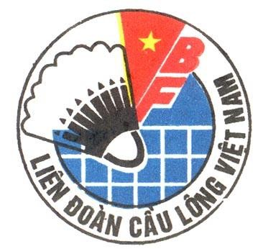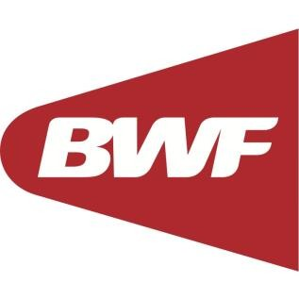
FLIGHT DETAILS FORM

Please complete and return this Form to hanoiba_vn@yahoo.com.vn or fax at +84 437185346
before/by 10th March 2017.

Name of Member Association:
Contact Person:
PHONE NUMBER: | MOBILE NUMBER:
FAX NUMBER: | E-MAIL:

Please type clearly in CAPITAL LETTERS.

Group 1 | ARRIVAL | DEPARTURE
Day/Date
Time
Flight No.
Total no. of person
Name of Group Leader
Airport | Noi Bai International Airport

Group 2 (if any) | ARRIVAL | DEPARTURE
Day/Date
Time
Flight No.
Total no. of person
Name of Group Leader
Airport | Noi Bai International Airport

