



PROSPECTUS

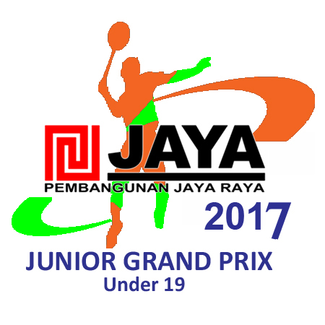

**Total Prize Money : $ 30,000**

**( $20,000 for U-19 and $10,000 for U-15/17 )**

**ENTRY CLOSING**

**International Players: 14 March 2017**

**Indonesian Players: 12 March 2017**

**11 - 16 APRIL 2017**

**PEMBANGUNAN JAYA RAYA**

**BADMINTON TRAINING CENTER**

**JAKARTA, INDONESIA**



**1. Organizer:** Badminton Association of Indonesia (PBSI)

Gedung Pusat Bulutangkis Indonesia

Jl. Damai Raya Kel/Kec. Cipayung

Jakarta Timur 13840, Indonesia

Phone : +62 21 8445078, 8445080

Fax : +62 21 8445079

E-mail : [sekjen@pbsi.or.id](mailto:sekjen@pbsi.or.id)

**2. Sanctioned by:** Badminton World Federation ( BWF )

Under 19 only Badminton Asia

**3. Technical Officials:**

* Referee : Mr. Ryan Tsai (TPE)
* Email : [ryan@deltec-hose.com.tw](mailto:ryan@deltec-hose.com.tw)
* Deputy Referee : Mr. Herman Subardjah (INA)
* Email : [hermansubarjah@gmail.com](mailto:hermansubarjah@gmail.com)

**4. Tournament Venue:** : PEMBANGUNAN JAYA RAYA

Badminton Training Center

Jl. Murai Raya, Bintaro

Jakarta, Indonesia

**5. Tournament Schedule:**

Day 1 Tue 11 April 2017 Qualifying Round

Day 2 Wed 12 April 2017 Preliminary Rounds

Day 3 Thu 13 April 2017 Preliminary Rounds

Day 4 Fri 14 April 2017 Quarter Finals

Day 5 Sat 15 April 2017 Semi-Finals

Day 6 Sun 16 April 2017 Finals

**Note:** *The schedule is subject to change at the discretion of the Referee*

**6. Age Category :** A. Boys and Girls Under 19 years old ( born 1999 or later )

B. Boys and Girls Under 17 years old ( born 2001 or later )

C. Boys and Girls Under 15 years old ( born 2003 or later )

**Note :** *A player can register in one age category only and passport will be used to verify players' age*

**7a. Prize Money U-19 : US $ 20,000**

|  |  |  |  |  |  |  |
| --- | --- | --- | --- | --- | --- | --- |
| **No** | **Event** | **Champion** | **Runner Up** | **Semi Final** | **Quarter Final** | **Last 16** |
| 1 | Boy’s Singles *  Girl’s Singles * | US$ 1,500 | US$ 760 | US$ 290 | US$ 120 | US$ 70 |
| 2 | Boy’s Doubles **  Girl’s Doubles **  Mixed Doubles** | US$ 1,580 | US$ 760 | US$ 280 | US$ 145 | US$ 75 |

* Medal & Souvenir for all winners and runners-up
* * Per Player ** Per Pair

**7b. Total Prize Money for U-17 & U-15 : US $ 10,000**

|  |  |  |  |  |  |
| --- | --- | --- | --- | --- | --- |
| **No** | **Event U-17** | **Champion** | **Runner Up** | **Semi Final** | **Quarter Final** |
| 1 | Boy’s Singles *  Girl’s Singles * | US$ 500 | US$ 250 | US$ 105 | US$ 60 |
| 2 | Boy’s Doubles **  Girl’s Doubles **  Mixed Doubles** | US$ 500 | US$ 250 | US$ 105 | US$ 60 |

|  |  |  |  |  |  |
| --- | --- | --- | --- | --- | --- |
| **No** | **Event U-15** | **Champion** | **Runner Up** | **Semi Final** | **Quarter Final** |
| 1 | Boy’s Singles *  Girl’s Singles * | US$ 400 | US$ 200 | US$ 100 | US$ 50 |
| 2 | Boy’s Doubles **  Girl’s Doubles ** | US$ 400 | US$ 200 | US$ 100 | US$ 50 |

* Medal & Souvenir for all winners and runners-up
* * Per Player ** Per Pair

**8. Closing Date For Entry : 14 March 2017**

23:59hours BWF Headquarters time, GMT +08:00

1. Member Associations are advised to log on to online entry system: <http://bwf.tournamentsoftware.com/sport/tournament.aspx?id=A9EB6A9E-9B7A-4DD0-9F7E-A9AF04E9DAFC>

b. You will require a username and password to submit your entries and this can be obtained from the BWF: please contact Mr. Shan at [s.ramachandran@bwfbadminton.org](mailto:s.ramachandran@bwfbadminton.org) . The online entry page will close immediately on the entries closing date at 23:59 hours BWF Headquarters time (+08:00h GMT) and you are required to submit the entries on time. Including technical error with system, late entries will not be accepted. If happen that you are faced with any entry difficulties, members association may contact Ms. Belle at [belleng@badmintonasia.org](mailto:belleng@badmintonasia.org) for assistance before entry dateline.

c. After the closing date, the BWF Online Entry System will send notification to all participating Member Associations confirming receipt of final entries. Receipt of this notification is the conclusive evidence of receipt of entries before the deadline. The Member Associations should contact BWF immediately if such notice is not received by the Wednesday (next day of the entries closing date) by noon BWF Headquarters time (+08.00h GMT) following close of entries. If no objection is received by BWF by Thursday (second day after the entries closing day) 23.59 hours BWF Headquarters time (+08.00h GMT) following the close of entries, the entries shall be deemed to be correct. No complaints / objections shall be entertained after this point.

d. **Entry for Indonesian players ;**

Indonesian players only: **Closing date is on Sunday, March 12, 2017 , you have to pass your entry through regional board of PBSI (** *Khusus untuk Pemain Indonesia, penutupan diadakan pada hari Minggu tanggal 12 Maret 2017 pukul 23:59 WIB. Pendaftaran dilakukan seperti Sirkuit Nasional, yaitu melalui masing-2 Pengprov )*

**9. Rules and Regulations:**

* The tournament will be run in accordance with the Laws of Badminton adopted by the Badminton World Federation (BWF) .
* All players must be registered members of a body affiliated with the BWF and must be in good standing with their Member Association.
* Shuttlecock : **YONEX Shuttles**
* All Players must wear badminton attire as per the BWF Competition Regulations 19-23.

**Compulsory Clothing Regulation**

**1.** Name of Player is Mandatory from the first day of event.

**2.** Quarter Finals onwards, doubles partners must wear clothing of same colour.

**3.** Quarter Finals onwards, opposing players must wear clothing of significantly different colors.

* Competition regulation can be found at www.bwfbadminton.org
* Scoring System : Rally Point System 3 x 21 points

**10. Seeding and Draw:** The following timelines will apply

Main and Qualifying **16th March 2017**

Seeding **23rd March 2017**

Last date for withdrawal w/o penalty **26th March 2017**

Draw **28th March 2017**

a. The seeding will be determined using BWF World Junior Rankings followed by the latest Badminton Asia U17 & U15 Junior ranking. The World Junior Rankings dated Thursday, **23rd March 2017** will be used.

b. The draw for the Pembangunan Jaya Raya Junior Grand Prix 2016 will be conducted by Badminton Asia on Tuesday, **28th March 2017**

c. Players are required to have a BWF ID Number to enter. Players requiring a new BWF ID Number are requested to apply at least 7 days prior to the closing date of the tournament. Players may contact the National Association accordingly.

d. **Draw Formats U-19, U-17 & U-15:**

|  |  |
| --- | --- |
| **Event** | **Entries - Main Draw** |
| Boy’s Singles | 128 |
| Girl’s Singles | 64 |
| Boy’s Doubles | 64 |
| Girl’s Doubles | 64 |
| Mixed Doubles  ( U-19,U-17) | 64 |

**11. Withdrawals**

* Notification of withdrawal(s) with reason must be given immediately to Badminton Association of Indonesia by fax or email and must be supported by a medical certificate. The organizers may require documentary evidence to support withdrawals for any other reason.
* If withdrawal arises after players have arrived at the venue, notification of withdrawal accompanied by supporting documentation must be made **IN PERSON** to the Referee or Deputy Referee.

**12. On-Court Docto**r :

* On-Court doctor will be on duty throughout the competition at the tournament venue.
* Players will be responsible for any travel and medical expenses incurred. It is recommended that all

participants have travel insurance.

* The organiser will **NOT** be responsible for any injury sustained, at any time, by any player or official arising from his participation in this tournament.
* Any costs incurred for medical treatment and / or hospitalisation shall be borne by the Member Association of the player / official concerned.

**13. Anti-doping regulations:**

* The BWF Anti-Doping Regulations apply at this BWF sanctioned event. Players competing in this

tournament are subject to ***in-competition drug testing*** under BWF Anti-Doping Regulations.

**14. Key dates for Meeting:**

**Team Managers Meeting:**

Date : **April 10th , 2017 (Monday)** Time: 15.00 pm

Venue : Jaya Raya Conference Room

**Umpires’ Briefing:**

Date : **April 10th , 2017 (Monday)** Time: 16.00 pm

Venue : Jaya Raya Conference Room

***Note :*** *Each participating team should appoint one Team Manager.*

*The Team Managers shall attend any briefings and meetings called by the Referee.*

**15. Accomodation:**

* **Airport** : **Soekarno Hatta Airport** , Jakarta, Indonesia

20 – 30 minutes to official hotels

* **Transportation** : The Organizing Committee will provide transportation from/to the **Soekarno Hatta International Airport** to/from the **Official Hotel** upon request. Please inform us of your exact flight details of arrival and departure **not later than March 16th, 2017.**

Ground transportation to and from the venue will only be provided to participants staying at the official hotel.

* **Practice Sessions** : for players will be arranged upon arrival.
* **Visa application** : for all player and officials, who require visa to enter Indonesia, should submit full passport details (Full name, Passport No, and Date of Issue & Expiry contact no.) to [sekjen@pbsi.or.id](mailto:sekjen@pbsi.or.id) not later than **March 16th, 2017.**

**16. Official Hotel**

: **Santika Hotel BSD City Grand Zuri BSD City**

Rate : IDR 590.000. ( approx US$ 45 ) IDR 690.000. ( approx US$ 53 )

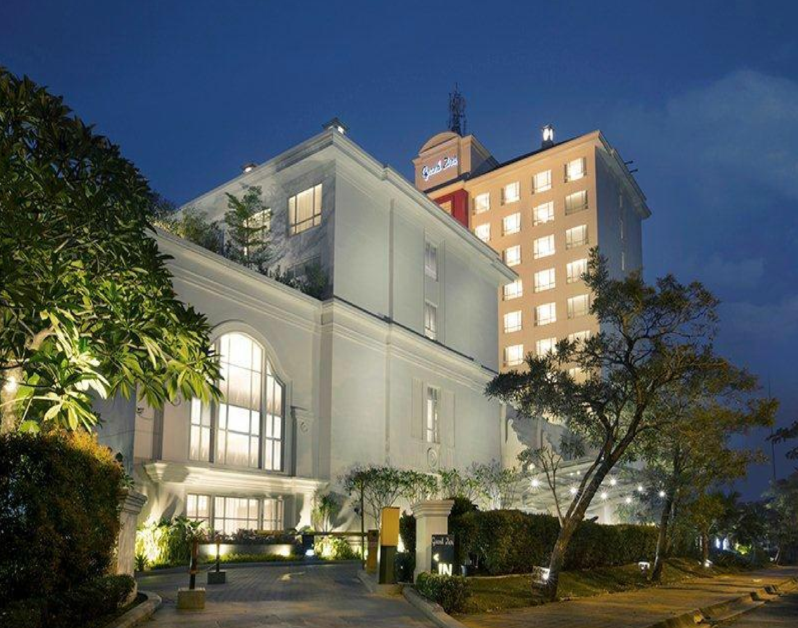

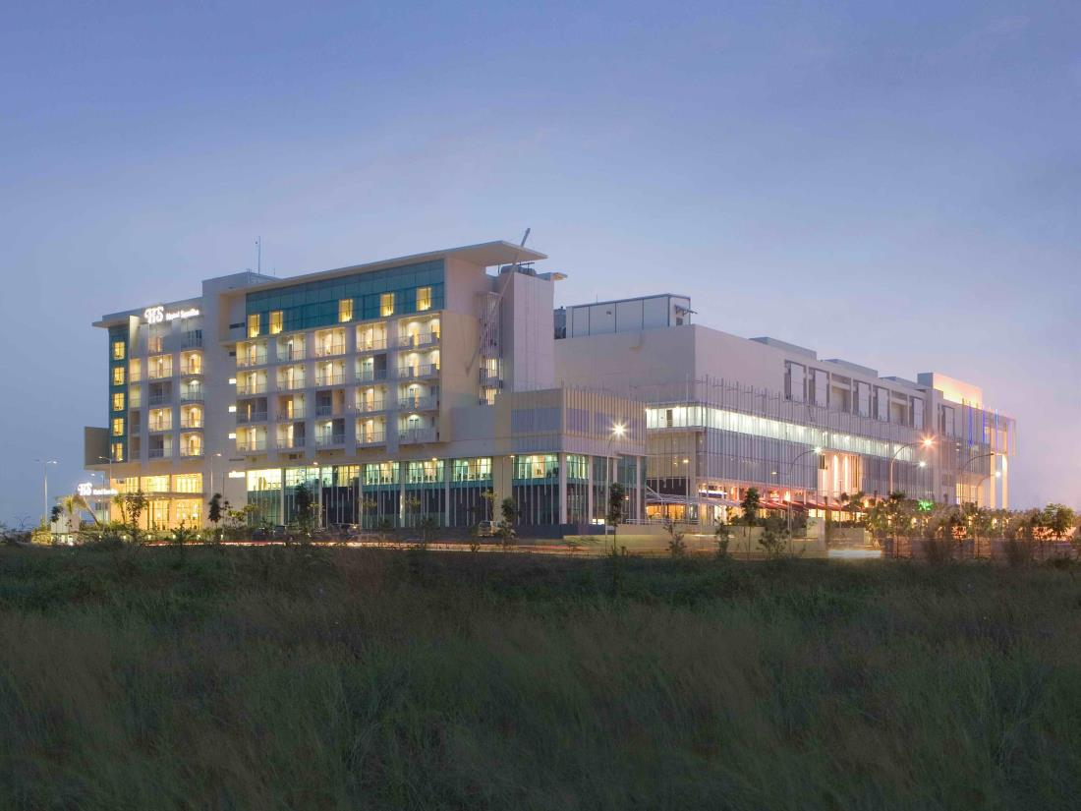

: **Pranaya** **Suites** **BSD** **City**

: IDR 625.000. ( approx. US$ 47 )

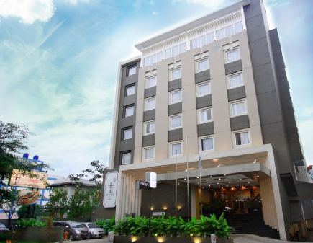

per room per night for 2 person include breakfast

Reservation received after **March 16th 2017** will be considered subject to room availability.

Please send the Room List Form to :

**1. Yuoan Rinto** email: [tournament@rajakamar.com](mailto:tournament@rajakamar.com)

**2. Ms. RosianaTendean** email : [rosiana_t@yahoo.com](mailto:rosiana_t@yahoo.com)

**Pembangunan Jaya Raya**

**Junior Grand Prix 2017**



TRANSPORT and Practice Court Request

**For International Competitors**

Please complete the following to assist tournament organisation and return to : **Ms. RosianaTendean**

email :[rosiana_t@yahoo.com](mailto:rosiana_t@yahoo.com) not later than **March 16th, 2017**

|  |  |
| --- | --- |
| **Officials :** | |
| **Name** | **Role** |
|  |  |
|  |  |

|  |
| --- |
| **Transport :** |
| What will the size of your group be ? |

|  |  |  |  |
| --- | --- | --- | --- |
| **Arrival in Soekarno Hatta International Airport :** | | | |
| Date : | Time : | | * AM |
| * PM |
| Airline : | Flight No : | | |
| Do you require transport from the Airport ? | | * YES | |
| * NO | |

|  |  |  |  |
| --- | --- | --- | --- |
| **Departure from Soekarno Hatta International Airport :** | | | |
| Date : | Time : | | * AM |
| * PM |
| Airline : | Flight No : | | |
| Do you require transport to the Airport ? | | * YES | |
| * NO | |

|  |  |  |  |
| --- | --- | --- | --- |
| **Practice Court Request :** | | | |
| Date | Time | No. Of Courts | No. Of Players |
|  |  |  |  |
|  |  |  |  |
| **Pembangunan Jaya Raya**  **Junior Grand Prix 2017** |  |  |  |

Please complete the following to assist tournament organisation and return to email :  **sekjen@pbsi.or.id**

not later than  **March 14th, 2017**

**ENTRY FORM**

**(Indonesian Players Only)**

|  |  |
| --- | --- |
| **Name of Member Association:** | |
| Contact Person: | |
| PHONE NUMBER: | MOBILE NUMBER: |
| FAX NUMBER | E-MAIL : |

|  |  |  |  |  |
| --- | --- | --- | --- | --- |
| **No.** | **BWF Id** | **Surname** | **First Name** | **Date of Birth** |
| **BOY’S SINGLE** | | | | |
| 1 |  |  |  |  |
| 2 |  |  |  |  |
| 3 |  |  |  |  |
| 4 |  |  |  |  |
|  |  |  |  |  |
| **GIRL’S SINGLE** | | | | |
| 1 |  |  |  |  |
| 2 |  |  |  |  |
| 3 |  |  |  |  |
| 4 |  |  |  |  |
|  |  |  |  |  |
| **BOY’S DOUBLES** | | | | |
| 1 |  |  |  |  |
| 2 |  |  |  |  |
| 3 |  |  |  |  |
| 4 |  |  |  |  |
| **BOY’S DOUBLES** | | | | |
| 1 |  |  |  |  |
| 2 |  |  |  |  |
| 3 |  |  |  |  |
| 4 |  |  |  |  |
| **MIXED DOUBLES** | | | | |
| 1 |  |  |  |  |
| 2 |  |  |  |  |
| 3 |  |  |  |  |
| 4 |  |  |  |  |
|  | | | | |

**Pembangunan Jaya Raya**

**Junior Grand Prix 2017**



Please complete the following to assist tournament organisation not later than **March 16th, 2017** and return to : **1. Yuoan Rinto** email:[tournament@rajakamar.com](mailto:tournament@rajakamar.com)

**2. Ms. RosianaTendean** email :[rosiana_t@yahoo.com](mailto:rosiana_t@yahoo.com)

|  |  |
| --- | --- |
| Name of Member Association: | |
| Contact Person: | |
| PHONE NUMBER: | MOBILE NUMBER: |
| FAX NUMBER | E-MAIL : |

|  |  |
| --- | --- |
| Hotel Name : | * Santika Hotel BSD City |
| * POP! Hotel BSD City |

**ROOM LIST**

|  |  |  |  |  |
| --- | --- | --- | --- | --- |
| **No. of Rooms** | **Deluxe** | **Full Name** | **Check-In** | **Check-Out** |
| **Standard** |
|  |  |  |  |  |
|  |  |  |  |  |
|  |  |  |  |  |
|  |  |  |  |  |
|  |  |  |  |  |
|  |  |  |  |  |
|  |  |  |  |  |
|  |  |  |  |  |
|  |  |  |  |  |

.